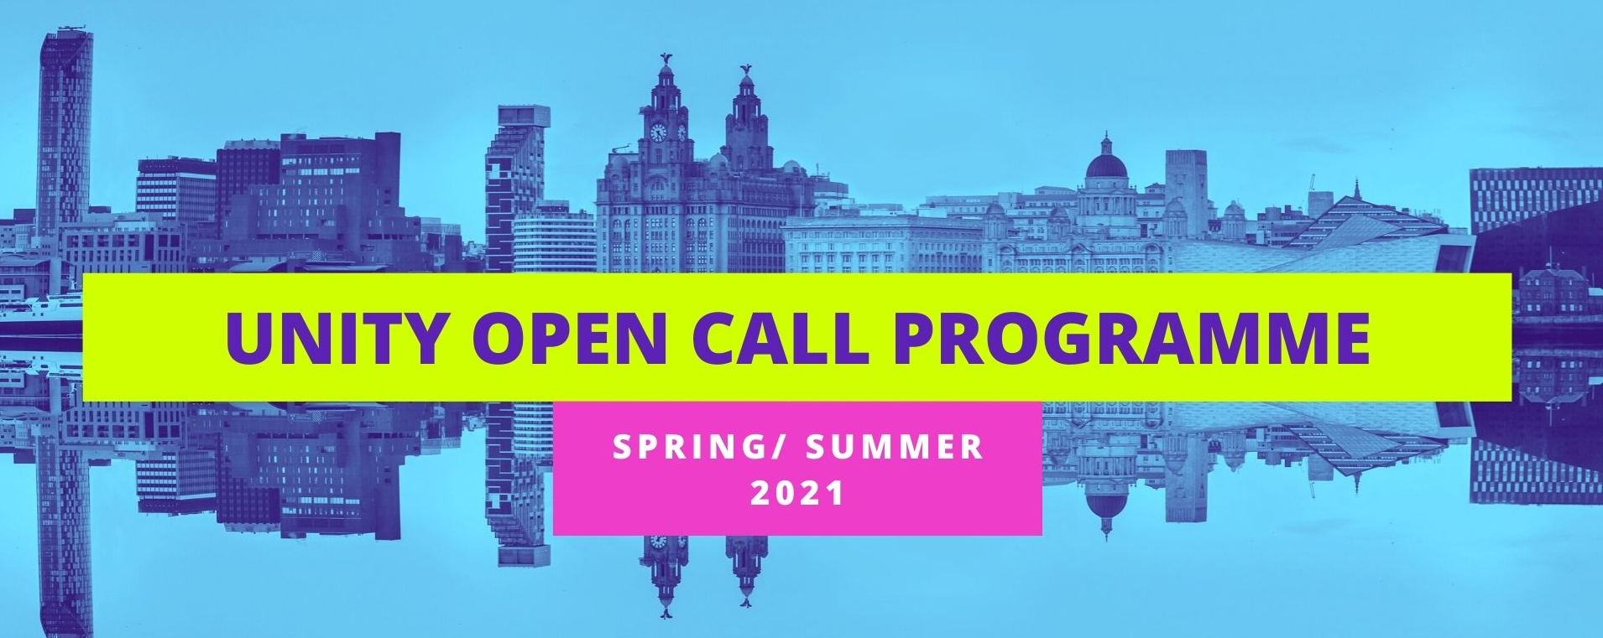
Expression of Interest Form – Open Call Online Commission
In no more than 1.5 sides of A4, please tell us about yourself and the work you wish to create with Unity for their new season of work, answering the following questions:
- Can you tell us a little bit about you?
- Can you tell us a bit abut the work you want to create?
- Why do you want to create this work?
- How developed is your idea?
- Aside from financial support, what else will you need from Unity (access support, technical, dramaturgy, training, access to a creative team)?
Please feel free to provide any supporting links:
Name:
Company Name (If applicable):
Email Address:
Postcode:

Please complete the form on the page below and email to artists@unitytheatre.co.uk.
If you require any support completing your application or would rather send in your answers via 2-minute video, please get in touch using the same email address.

