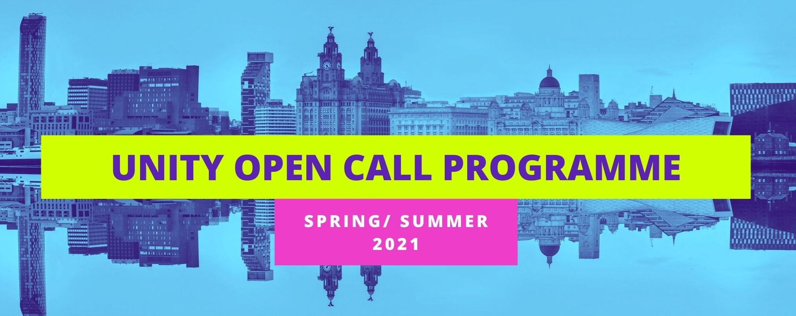
Expression of Interest Form – Open Call Programme
In no more than 1.5 sides of A4, please tell us about yourself and the work you wish to present as part of Unity’s Open Call Programme, answering the following questions:
- Can you tell us a little bit about you and your work?
- Is the work to be performed online, in venue or in another location?
- How developed is the work?
- When will it be ready to be performed (between February and May)?
- Why is it a good suit for our reopening programme?
Please feel free to provide any supporting links to previous work.
Name:
Company Name (If applicable):
Email Address:
Postcode:

Please complete the form on the page below and email to artists@unitytheatre.co.uk.
If you require any support completing your application or would rather send in your answers via 2-minute video, please get in touch using the same email address.

